 



Database Programming with SQL 15-2: DML Operations and Views Practice Activities

# Objectives

* Write and execute a query that performs DML operations on a simple view
* Name the conditions that restrict modifying a view using DML operations
* Write and execute a query using the WITH CHECK OPTION clause
* Explain the use of WITH CHECK OPTION as it applies to integrity constraints and data validation
* Apply the WITH READ ONLY option to a view to restrict DML operations

# Vocabulary

Identify the vocabulary word for each definition below.

|  |  |
| --- | --- |
| **ROWNUM** | A pseudocolumn which assigns a sequential value starting with 1 to each of the rows returned from the subquery |
| **WITH CHECK OPTION** | Specifies that INSERTS and UPDATES performed through the view can’t create rows which the view cannot select |
| **WITH READ ONLY** | Ensures that no DML operations can be performed on this view |

# Try It / Solve It

Use the DESCRIBE statement to verify that you have tables named copy_d_songs, copy_d_events, copy_d_cds, and copy_d_clients in your schema. If you don't, write a query to create a copy of each.

CREATE TABLE copy_d_songs

AS ( SELECT * FROM d_songs);

DESCRIBE copy_d_songs;

DESCRIBE d_songs;

SELECT * FROM d_songs;

SELECT * FROM copy_d_songs;

CREATE TABLE copy_d_events

AS ( SELECT * FROM d_events);

DESCRIBE copy_d_events ;

DESCRIBE d_events;

SELECT * FROM d_events ;

SELECT * FROM copy_d_events ;

CREATE TABLE copy_d_cds

AS ( SELECT * FROM d_cds);

DESCRIBE copy_d_cds;

DESCRIBE d_cds;

SELECT * FROM d_cds;

SELECT * FROM copy_d_cds ;

CREATE TABLE copy_d_clients

AS ( SELECT * FROM d_clients);

DESCRIBE copy_d_clients ;

DESCRIBE d_clients;

SELECT * FROM d_clients ;

SELECT * FROM copy_d_clients ;

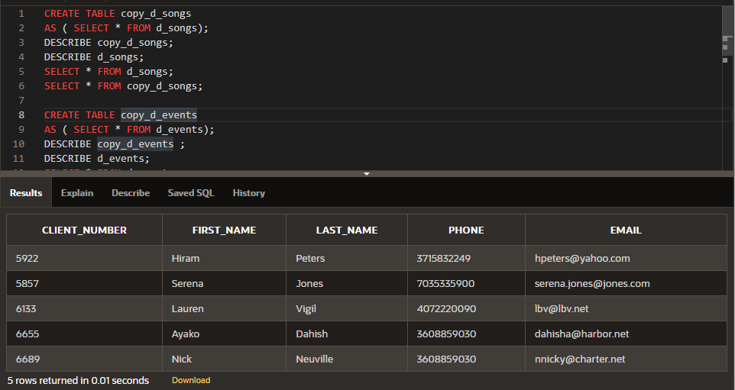

1. Query the data dictionary USER_UPDATABLE_COLUMNS to make sure the columns in the base tables will allow UPDATE, INSERT, or DELETE. Use a SELECT statement. All table names in the data dictionary are stored in uppercase.

SELECT owner, table_name, column_name, updatable,insertable, deletable

FROM user_updatable_columns WHERE LOWER(table_name) = 'copy_d_songs';

SELECT owner, table_name, column_name, updatable,insertable, deletable

FROM user_updatable_columns WHERE LOWER(table_name) = 'copy_d_events';

SELECT owner, table_name, column_name, updatable,insertable, deletable

FROM user_updatable_columns WHERE LOWER(table_name) = 'copy_d_cds';

SELECT owner, table_name, column_name, updatable,insertable, deletable

FROM user_updatable_columns WHERE LOWER(table_name) = 'copy_d_clients';

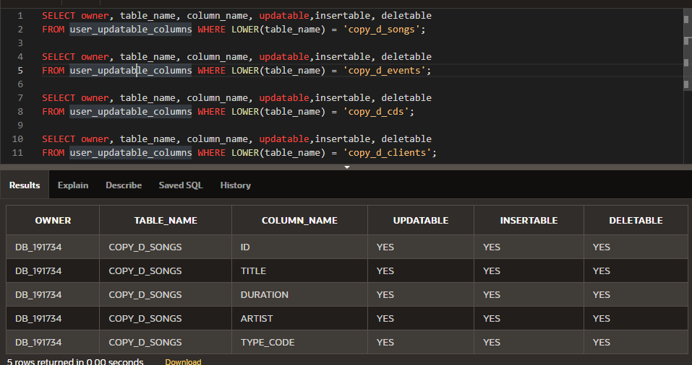

1. Use the CREATE or REPLACE option to create a view of *all* the columns in the copy_d_songs table called view_copy_d_songs.

CREATE OR REPLACE VIEW view_copy_d_songs AS

SELECT *

FROM copy_d_songs;

SELECT * FROM view_copy_d_songs;

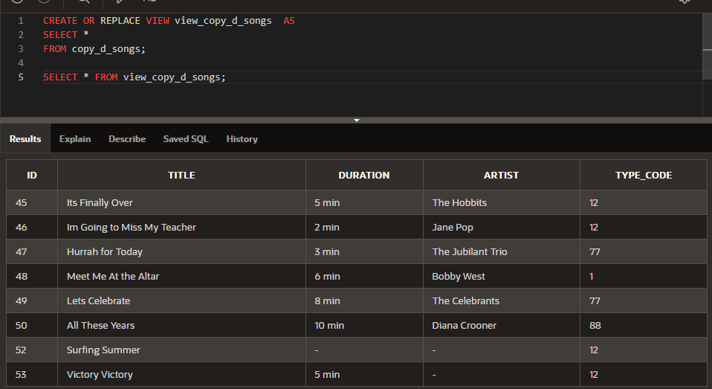

1. Use view_copy_d_songs to INSERT the following data into the underlying copy_d_songs table. Execute a SELECT * from copy_d_songs to verify your DML command. See the graphic.

|  |  |  |  |  |
| --- | --- | --- | --- | --- |
| ID | TITLE | DURATION | ARTIST | TYPE_CODE |
| 88 | Mello Jello | 2 | The What | 4 |

INSERT INTO view_copy_d_songs(id,title,duration,artist,type_code)

VALUES(88,'Mello Jello','2 min','The What',4);

Select * from view_copy_d_songs

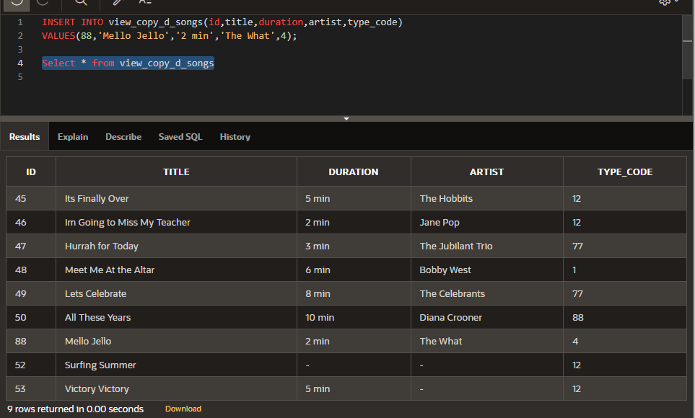

1. Create a view based on the DJs on Demand COPY_D_CDS table. Name the view read_copy_d_cds. Select all columns to be included in the view. Add a WHERE clause to restrict the year to 2000. Add the WITH READ ONLY option.

CREATE OR REPLACE VIEW read_copy_d_cds AS

SELECT *

FROM copy_d_cds

WHERE year = '2000'

WITH READ ONLY ;

SELECT * FROM read_copy_d_cds;

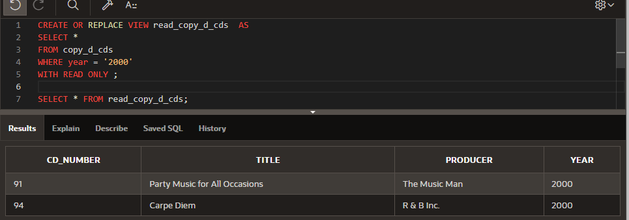

1. Using the read_copy_d_cds view, execute a DELETE FROM read_copy_d_cds WHERE cd_number = 90;

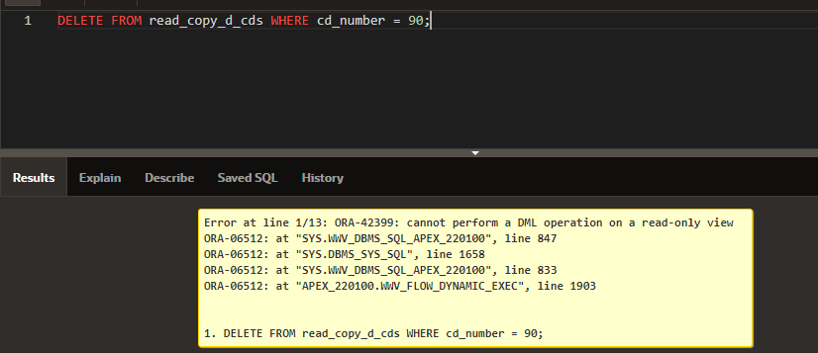

1. Use REPLACE to modify read_copy_d_cds. Replace the READ ONLY option with WITH CHECK OPTION CONSTRAINT ck_read_copy_d_cds. Execute a SELECT * statement to verify that the view exists.

CREATE OR REPLACE VIEW read_copy_d_cds AS

SELECT *

FROM copy_d_cds

WHERE year = '2000'

WITH CHECK OPTION CONSTRAINT ck_read_copy_d_cds;

1. Use the read_copy_d_cds view to delete any CD of year 2000 from the underlying copy_d_cds.

DELETE FROM read_copy_d_cds

WHERE year = '2000';

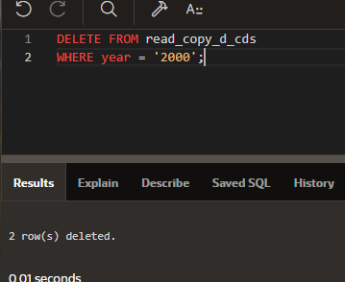

1. Use the read_copy_d_cds view to delete cd_number 90 from the underlying copy_d_cds table.

DELETE FROM read_copy_d_cds

WHERE cd_number = 90;

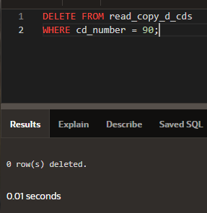

1. Use the read_copy_d_cds view to delete year 2001 records.

DELETE FROM read_copy_d_cds

WHERE year = '2001';

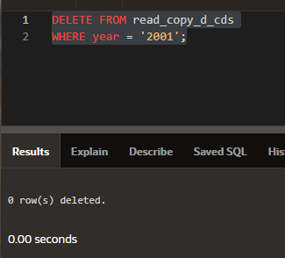

1. Execute a SELECT * statement for the base table copy_d_cds. What rows were deleted?

SELECT * from copy_d_cds

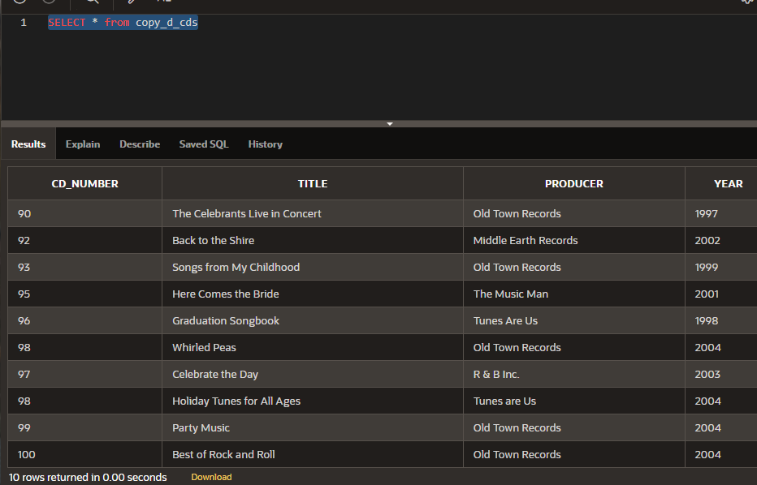

Только строки под запрос из 7 задания были удалены

1. What are the restrictions on modifying data through a view?

**Delete ограничения следующие**

Group functions

GROUP BY CLAUSE

DISTINCT

pseudocolumn ROWNUM  Keyword

**Modify ограничения следующие**

Group functions

GROUP BY CLAUSE

DISTINCT

pseudocolumn ROWNUM Keyword

*Column defined by expressions*

**INSERT ограничения следующие**

Group functions

GROUP BY CLAUSE

DISTINCT

pseudocolumn ROWNUM Keyword

Column defined by expressions

*Does not include NOT NULL columns in the base table.*

1. What is Moore’s Law? Do you consider that it will continue to apply indefinitely? Support your opinion with research from the internet.

Мур предполагал, что вычислительные мощности удваиваются каждый год, но учитывая особенность экспоненциальной функции это не будет продолжаться вечно.

1. What is the “singularity” in terms of computing?

Это гипотеза о том, что искусственный интеллект резко приведет к росту технологического прогресса, что отразится в глобальных изменениях жизнедеятельности человека.

Copyright © 2020, Oracle and/or its affiliates. All rights reserved. Oracle and Java are registered trademarks of Oracle and/or its affiliates. Other names may be trademarks of their respective owners.